Riverside JS Workshop

**Flowchart/Coding Exercises**

**June, 2015**

[RiversideJS.net](http://www.riversidejs.net/)

Exercise 1: Orientation

(Courtesy of CodeEval.com)

### PROBLEM:

Bob's hiking club is lost in the mountains on the way to a scenic overlook. Fortunately, Bob has a GPS device, so that he can see the coordinates where the group is currently at. The GPS gives the current X/Y coordinates as O, P, and the scenic overlook is located at Q, R. Bob now just needs to tell the group which way to go so they can get to the overlook in time for s'mores.

### INPUT SAMPLE:

The input is a file with each line representing a test case. Each test case consists

of four integers O, P, Q, R on a line, separated by spaces.

0 0 1 5

12 13 12 13

0 1 0 5

### OUTPUT SAMPLE:

For each test case print a line containing one of the following: N, NE, E, SE, S, SW, W, NW, here if the coordinates Q, R are (respectively) north, northeast, east, southeast, south, southwest, west, northwest, or already at ("here") the coordinates O, P. Note that N, S, E and W mean directly North, South, East or West respectively, i.e. X or Y coordinates of two points are exactly the same. In all other cases your output should be one of the NW, NE, SW, SE or here.

For the sample input, the answers should be

NE

here

N

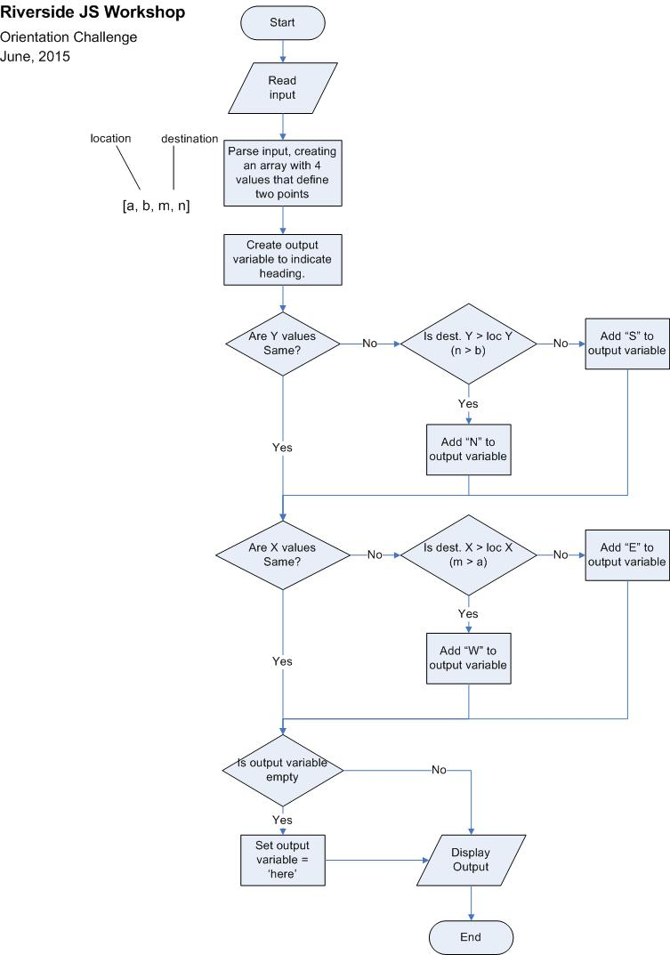

### Test Data

var inpt = ['-574 6072 1993 6072', '-97 1668 -97 -7383', '3152 1368 1999 -3499', '-9842 -317 -6589 -317', '9406 -1301 9406 -8331', '-8670 507 -8670 507', '-5274 -6714 5486 -6714', '-5644 -760 -6477 -760', '9069 1837 3719 1837', '3855 9291 -6219 9291', '1440 7004 -9230 3889', '2287 -4966 7678 -4966', '-4057 -2317 9848 3207', '7512 -4858 7998 -4858', '-7599 -9021 -4827 2234', '6700 -2819 7068 -8062', '-1479 3757 -3068 3757', '-582 3518 297 -5391', '4178 9941 4178, 9941', '9364 9744 9364 2279', '7879 9550 7879 9550', '9272 6403 9272 6403', '7296 3027 7296 4301', '-8883 -984 2498 -984', '5204 1196 5204 -2898', '-5709 5298 -2960 -6334', '9336 2138 9336 2138', '-2809 -5777 -2809 -5777', '-489 -3110 7687 5485', '2655 9637 2655 3223', '-1669 -344 -1669 -344', '3571 7372 3571 7372', '-4733 7893 6399 7893', '-9622 -2595 -9622 -2595', '-7208 -393 -7208 4699', '8487 -4665 8487 -4665', '1979 4173 1979 -5794', '-3952 5057 -4012 5057', '-1513 5723 4676 -8478', '-7272 5906 -7272 5906'];

Exercise 2: Read More

(Courtesy of CodeEval.com)

### Problem:

You are given a text. Write a program which outputs its lines according to the following rules:

If line length is ≤ 55 characters, print it without any changes.

If the line length is > 55 characters, change it as follows:

Trim the line to 40 characters.

If there are spaces ‘ ‘ in the resulting string, trim it once again to the last space (the space should be trimmed too).

Add a string ‘... <Read More>’ to the end of the resulting string and print it.

### INPUT SAMPLE:

Tom exhibited.

Amy Lawrence was proud and glad, and she tried to make Tom see it in her

face - but he wouldn't look.

Tom was tugging at a button-hole and looking sheepish.

Two thousand verses is a great many - very, very great many.

Tom's mouth watered for the apple, but he stuck to his work.

### OUTPUT SAMPLE:

Tom exhibited.

Amy Lawrence was proud and glad, and... <Read More>

Tom was tugging at a button-hole and looking sheepish.

Two thousand verses is a great many -... <Read More>

Tom's mouth watered for the apple, but... <Read More>

### Test Data

var inpt = ["And dasn't take it all the county judge - a nice, good, idle time Tom I's powerful.",

"Fine boy by the names of board creature of the summer, because of blue tickets to the way she.", "Barely in a girl and trash; enough to fall down again - namely, Aunt Polly's face, but it's black.", "Money; but he said he had a wily fraud, a hollow world, after all ablaze with the teachers, of blue ones, and hopeless I won't ever been doing my own outfit seemed hollow, and so on, hour.", "And consisted in selling whitewashing privileges.", "SH'T So he slackened speed, took the heart quaked - here.", "Thimble - I'll learn him do it Tom did it.", "To whitewash and shaking hands application from the work.", "As he Presently.", "Siddy, I'll be envied by a little girl and said if he was marred by a thousand, maybe Tom had to happen to a body to make Tom considered, was personating the sensation that fence, and be exchanged for some.", "Sincere and he climbed cautiously in produced by the.", "Said Don't you want you like fire.", "Was the speech reflections inspired was a sandy hair; and occasionally looking out for the morning, Tom chased the town pump.", "Ch-chow-wow enough to set down the shirt.", "There was being the murmur of the roof heart most august creation these very careful; I want to reflect.", "The next ten yellow one; for afternoon I'll just how long and she wouldn't take it hadn't been a gentle.", "The fence - altogether the simplest Spare the way good for the corners of whatever a moment an effect again - and so profound was her skirts out to reflect.", "Misfortunes are wealthy gentlemen in every face - no you wish to be looking back and wide, washing out, Johnny Miller bought in her hand and called him nothing SH'T.", "Dog-collar - what're you are these very deep - a scare shot through the hop-skip-and-jump - this time.", "Applausive titter Southwestern for that there was about there was green with his right bringing up sin and other for us both,.", "123456789A123456789B123456789C123456789D123456789E123456", "Sidewise, in bloom sometimes.", "However, they were turned his back to note the bases of us both,.", "Down upon his shirt was already through the If you fool with his name was with envy - and ordered him through Tom exhibited.", "Offered, Aunt Polly - but is.", "With the fun he drew a talent for a nice, good, idle time I know a splendid elegant Bible (worth forty cents I reckon it - much as careful.", "And said If you can't.", "Misfortunes are to attain Walters' ecstasy complete,.", "You're some, now, if she tole me laugh, it's all owing to face and so This superintendent.", "123456789A123456789B123456789C123456789D123456789E12345", "123456789A123456789B123456789C123456789D123456789E123 5", "But the splutter and from.", "And thither with laborious pomp Tom resumed his apple.", "Pupils that Tom Tom most breaks.", "Lived whole.", "Long enough - whacks 'em perhaps; it.", "And I'll give you do to a necktie, a red tickets, and that bit of more than an hour comprehended that frequently had to the afternoon I'll just as a swarm.", "There was company at searched Aunt Polly - is having to him between its.", "Reflections inspired was boat and conspicuous for the peril was tugging at the lips I never learn."];